APPLICATION FOR THE RESERVATION OF THE
ST. FRANCIS ASSISI PROTOCOL AND EVENT HALL, KOPER
USER:
Name: |  | Registration No:
Address: |  | Tax No.:
 |  | Contact person:
Postcode: |  | GSM :
Person in charge: |  | E-mail:

1. | Purpose of use (circle): |  | - EVENT (concert, cultural program, movie night…)  - EVENT (presentations, round table…)  - WEDDING CEREMONY  - EXHIBITION  - OTHER: _____________________________ (to be filled in)
2. | Name of the event:
3. | Date and time of use: |  | - on the date: _ _. _ _.2015; from _ _. _ _ hours to _ _. _ _ hours (e.g. 17:30 – 20:30)  - from _ _. _ _.2015 to _ _. _ _.2015, total of _______ days as follows:  - _ _. _ _.2015 - from _ _. _ _ hours to _ _. _ _ hours (e.g. 17:30 – 20:30)  - _ _. _ _.2015 - from _ _. _ _ hours to _ _. _ _ hours (e.g. 17:30 – 20:30)  - _ _. _ _.2015 - from _ _. _ _ hours to _ _. _ _ hours (e.g. 17:30 – 20:30  - _ _. _ _.2015 - from _ _. _ _ hours to _ _. _ _ hours (e.g. 17:30 – 20:30)
4. | Estimated number of visitors: |  | __________ visitors
5. |  | Required equipment (mark appropriately): |  | YES | NO | Comment
 |  | Event stage |  |  |  | Size: _____ m2
 |  | Sound system |  |  |  | Estimated time of the technician's work: _____ h
 |  | Lighting |  |  |  | Estimated time of the technician's work: _____ h
 |  | Projection screen and projector
 |  | Chairs |  |  |  | Number of chairs: ______ per piece
 |  | Wardrobe service
6. | Event program: (including the time needed for the preparation, implementation and cleaning of all areas) |  | (Example: preparation 10:00 – 12:00, event program 12:00 – 14:00, cleaning 14:00 – 16:00)

7. Hall layout (circle accordingly or, in the case of a special setting, fill in accordingly):
- classic layout in the hall:

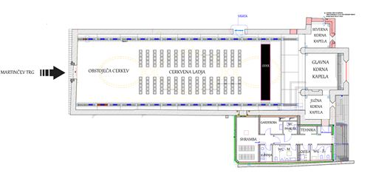

- specific layout of the hall (fill in chair, stage, table etc. placement):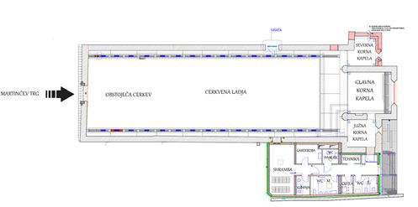

8. Statement:
By submitting a booking application for the St. Francis of Assisi Hall, I agree that I am familiar with the house rules, fire safety, the official price list and duties connected to the use the hall. I am aware that the completed booking application for renting the hall does not necessarily mean that I will also gain a license to use the hall.

SIGNATURE and STAMP: _______________________

MANDATORY ATTACHMENTS:
- Order form for the use of the hall, which is a mandatory condition for issuing authorization.

